1. For the following problem, the shortest path is determined manually using the label correcting algorithm:

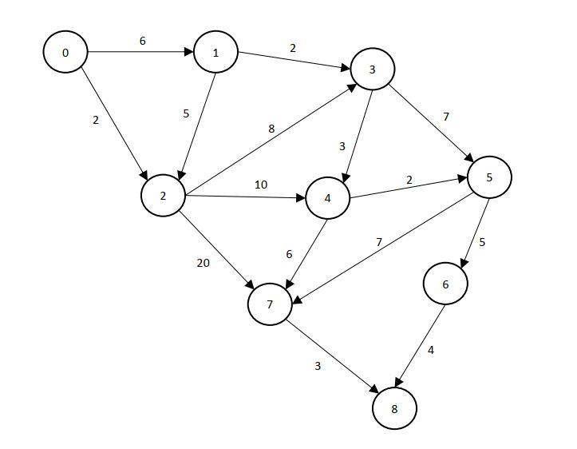

**Step 1:**

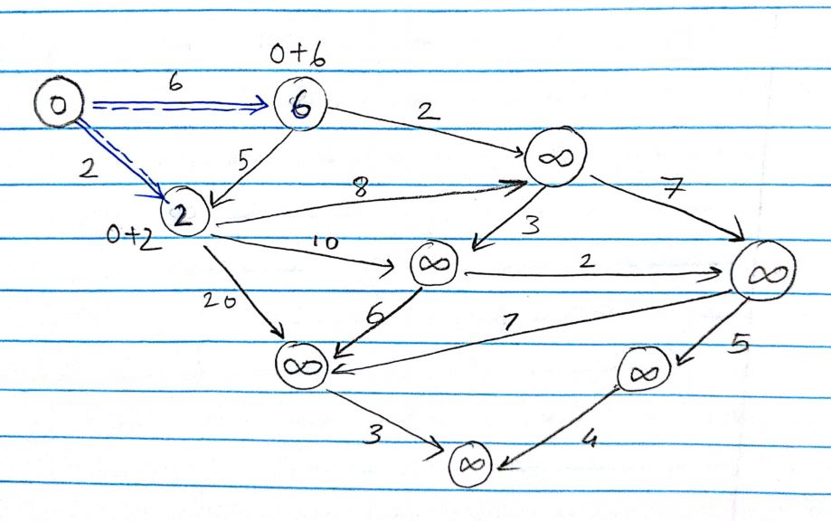

The origin label is made “0” and the adjacent label has been found.

**Step 2:**

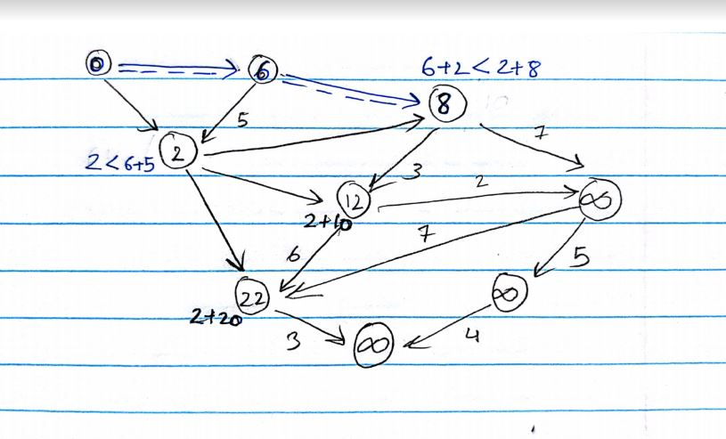

Starting from label 6, the two-next label has been changed according to the distance given between them,

**Step 3:**

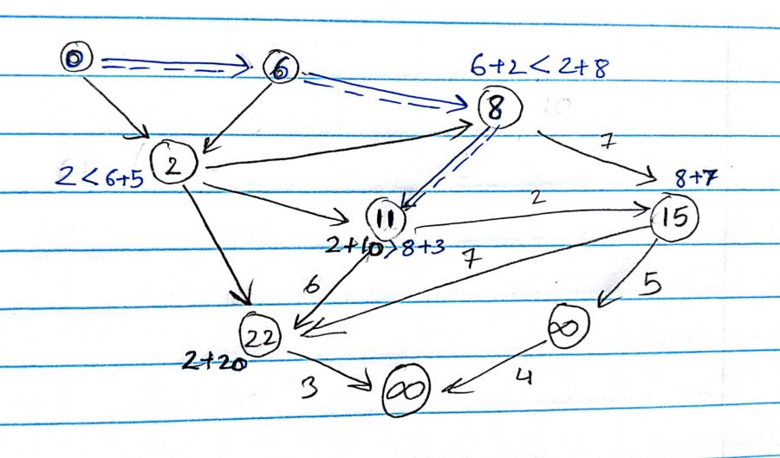

Now, considering the label 6, its adjacent label has been calculated and the lower value is chosen to be its next label of 8 and from 8 the next smallest label is chosen to be 11.

**Step 4:**

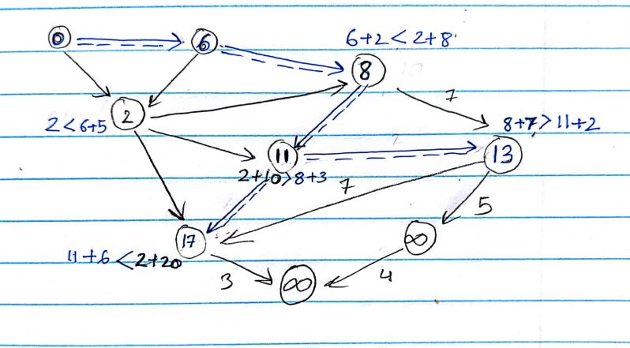

Similarly, the step is repeated for label 11 and the adjacent label is obtained to be 13 and 17.

**Step 5:**

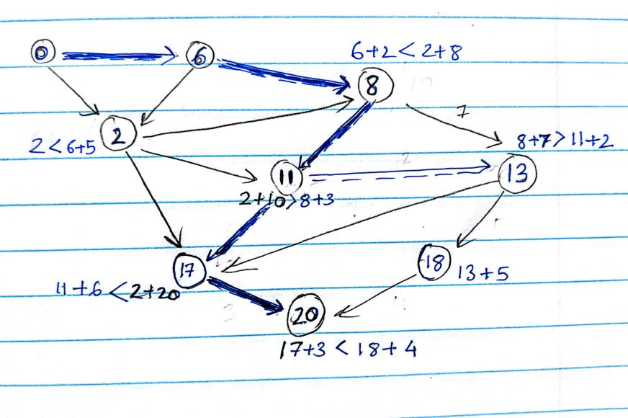

Finally, the label has been corrected with respect to label 6 and the destination label has been found. The total cost is 20.

Manually, the shortest path can be calculated as:

0 → 6 → 8 → 11 →17 →20

1. This problem has been solved using python and the output csv file is shown below, the python code is shown in GitHub



Using python code, the shortest path is calculated as:

0 → 1 → 3 → 4 →7 →8

And the cost is 20 which is equal to the one obtained by doing manually using label correcting algorithm.

1. The created network is shown below:

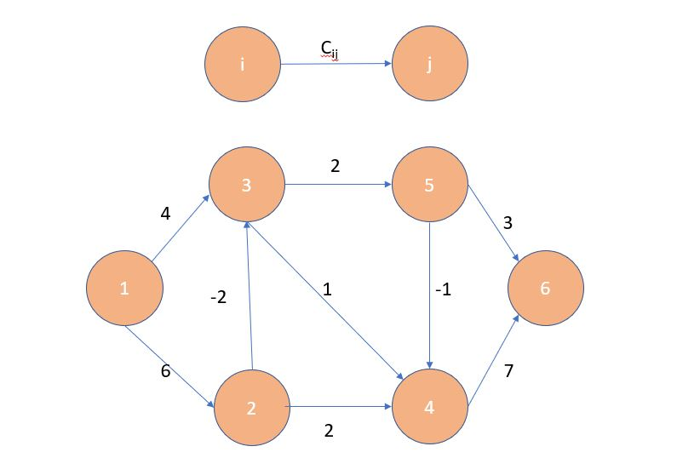

**Step 1:**

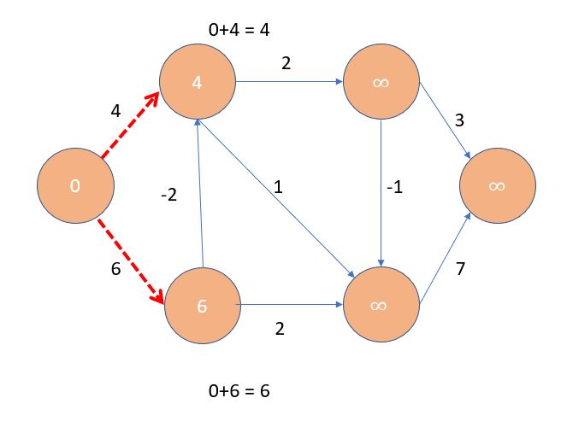

The origin label is made “0” and the adjacent label has been found.

**Step 2:**

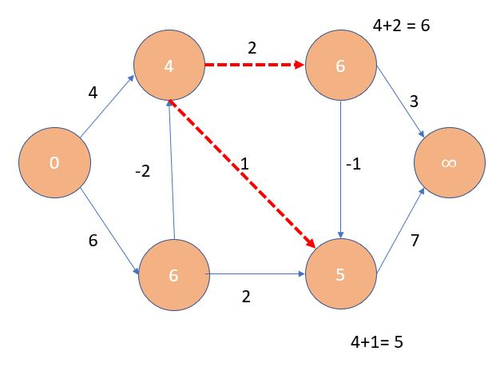

Starting from label 4, the two-next label has been changed according to the distance given between them,

**Step 3:**

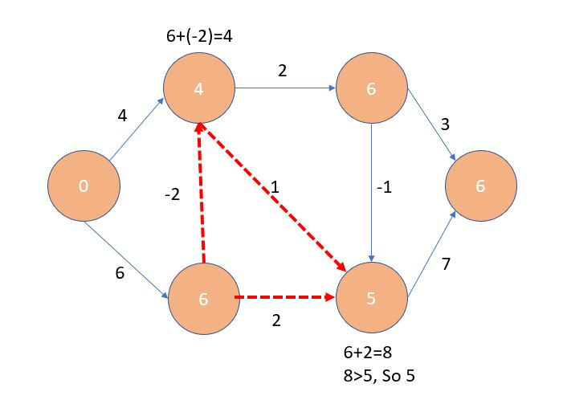

Now, considering the label 6, its adjacent label has been calculated and the lower value is chosen to be its next label.

**Step 4:**

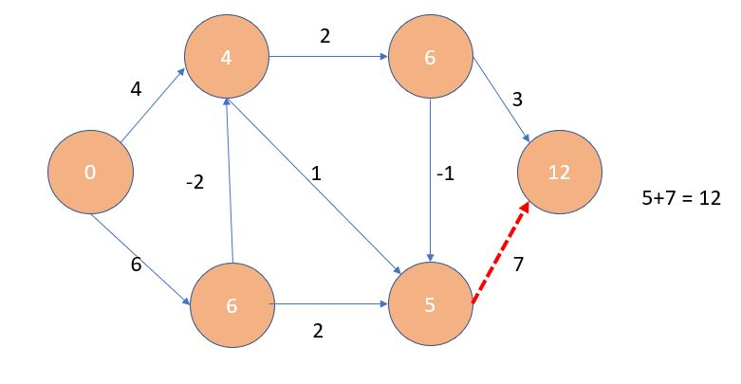

Similarly, the step is repeated for label 5 and the destination label has been found, but that is no the final label.

**Step 5:**

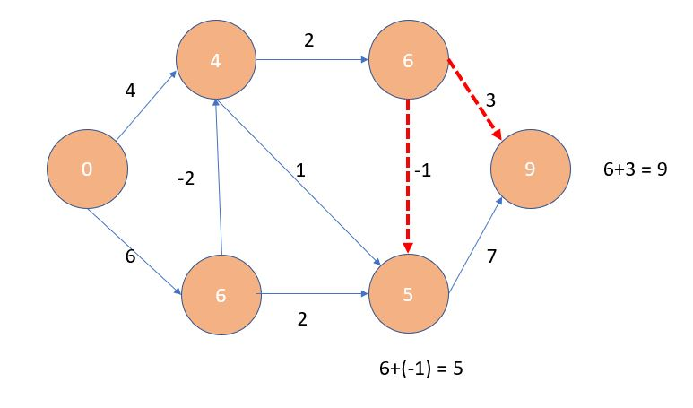

Finally, the label has been corrected with respect to label 6 and the destination label has been found.

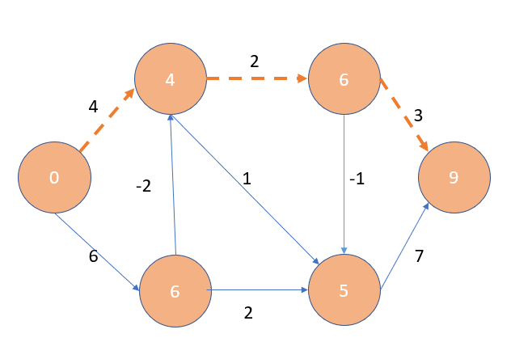

Manually, the shortest path can be calculated as:

0 → 4 → 6 → 9 (total cost =9)

Using the python code, the output is shown below, and the code is similar to that of previous question.

